Velociraptor DFIR Analysis Report

1. Introduction
This project demonstrates the use of Velociraptor for Digital Forensics and Incident Response (DFIR). The objective was to collect and analyze process and network artifacts from a Windows client system to identify potential Indicators of Compromise (IOCs).

2. Lab Setup
Server: Kali Linux running Velociraptor server
Client: Windows Virtual Machine with Velociraptor agent installed
Network: Host-only network configuration enabling communication between VMs
Red Team Tool: MITRE Caldera (used for simulation)

3. Data Collection
Artifacts collected using Velociraptor:
- Windows.System.Pslist (Process Information)
- Windows.Network.NetstatEnriched (Network Connections)
Data was exported in CSV format for further analysis.

4. Process Analysis
Multiple system and user processes were analyzed, including:
- svchost.exe (Windows Service Host)
- sihost.exe (Shell Infrastructure Host)
- ShellHost.exe (Windows UI component)
- fontdrvhost.exe (Font Driver Host)
- chrome.exe (User browser process)
All processes were verified to:
- Run from legitimate directories (C:\Windows\System32 or Program Files)
- Be digitally signed by trusted publishers (Microsoft or Google)
- Exhibit expected behavior without anomalies

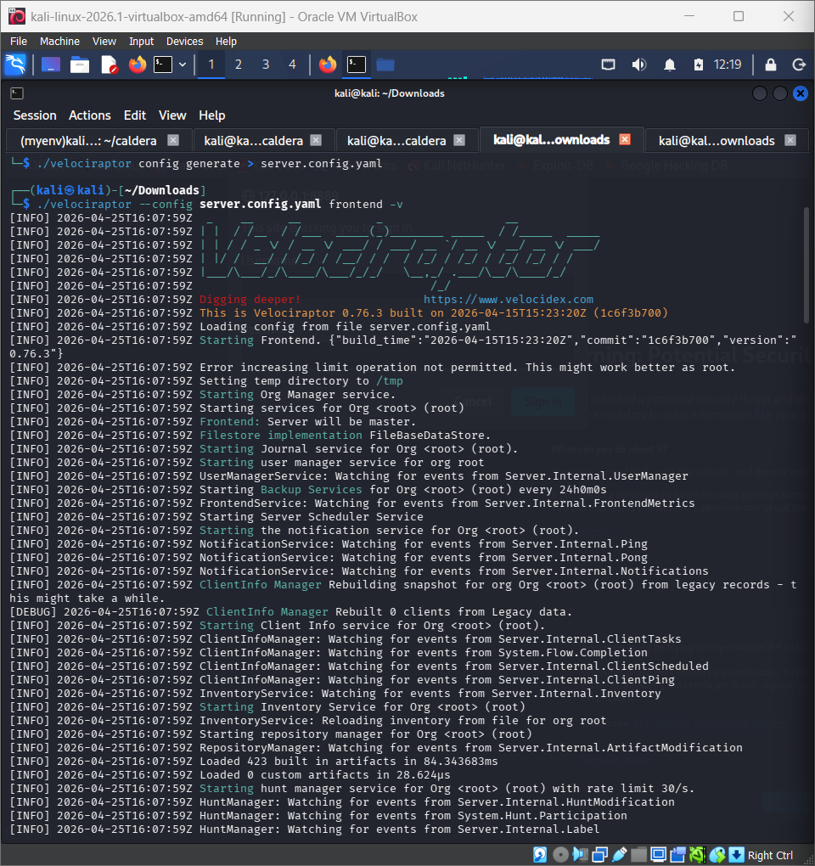

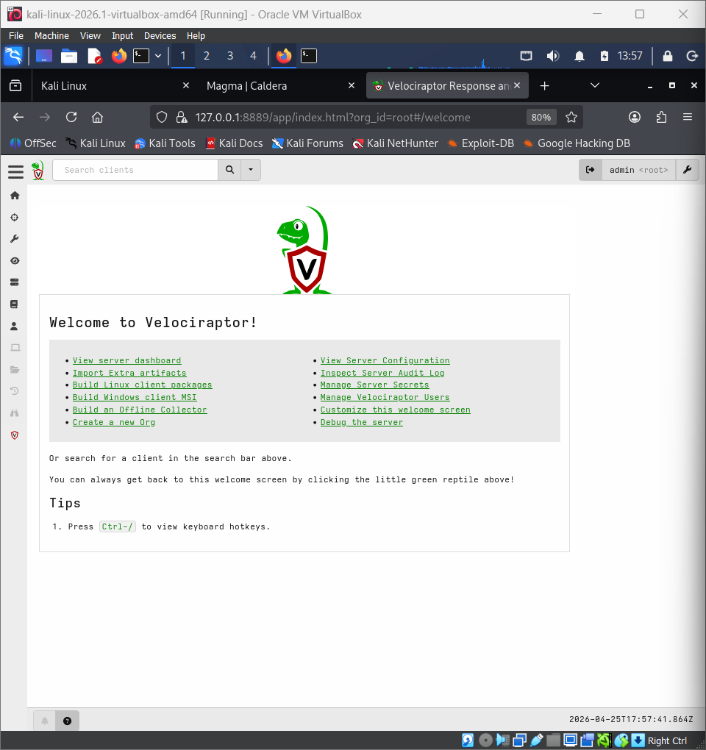

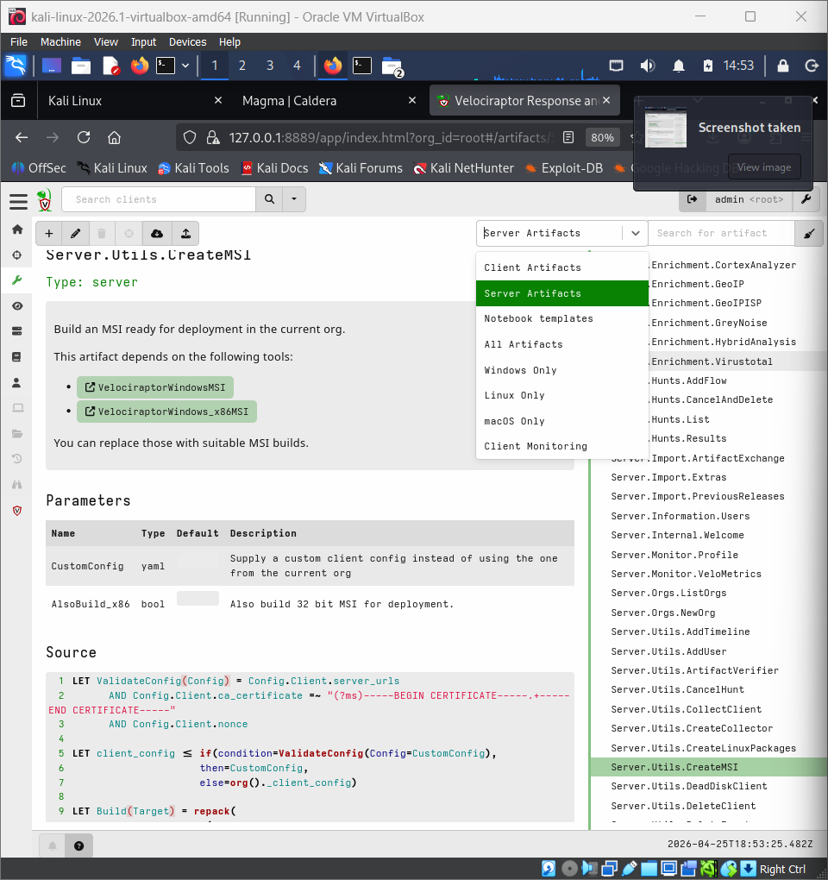

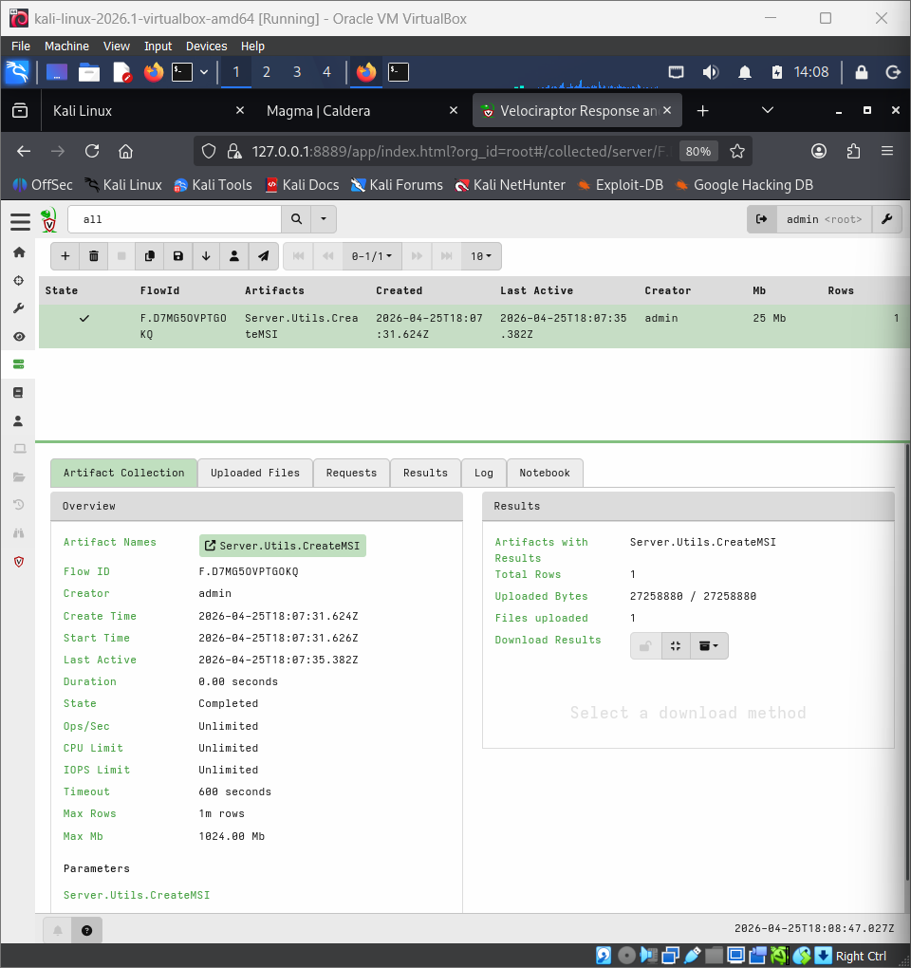

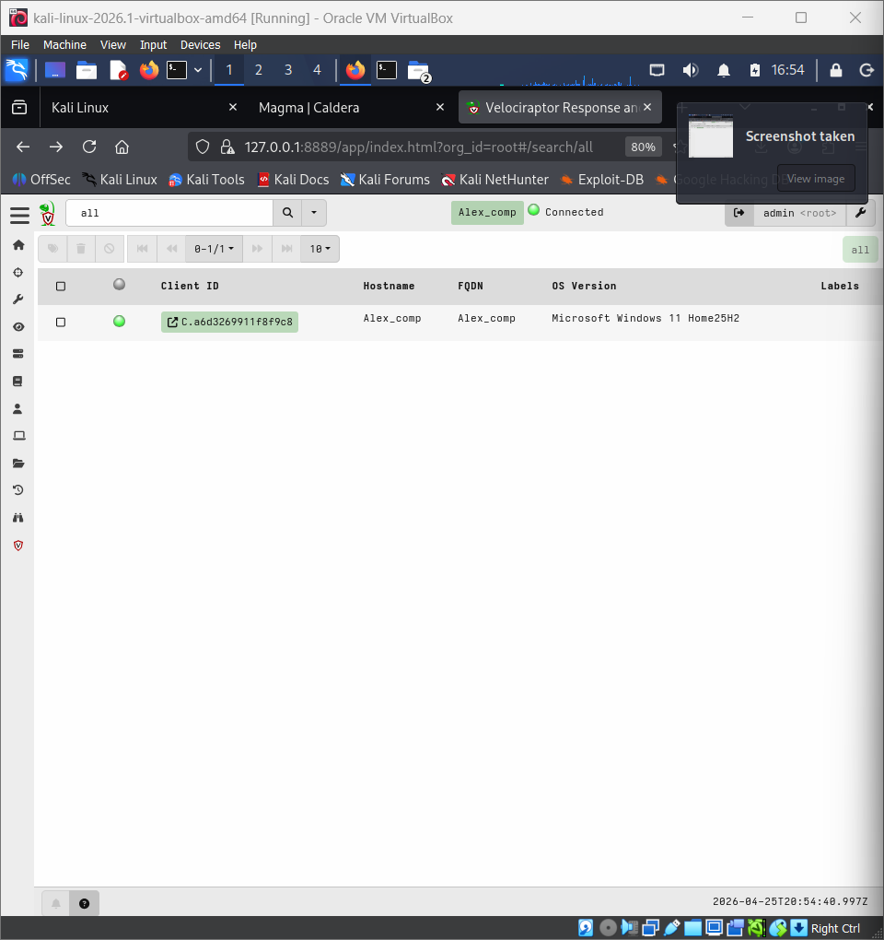

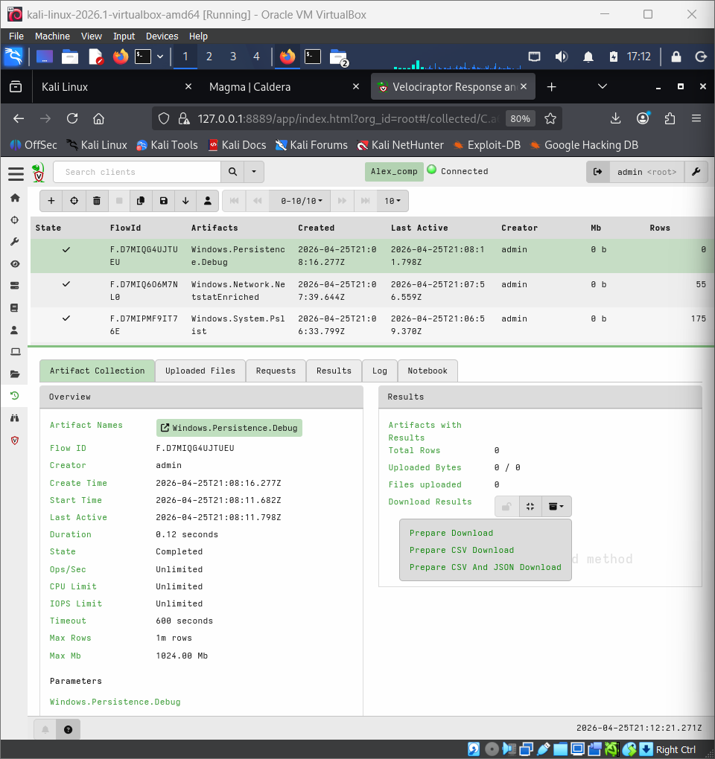

5. Network Analysis
Network connections were analyzed from the Netstat artifact:
- Internal communication (127.0.0.1 and 192.168.x.x)
- Browser connection to Velociraptor server (port 8889)
- Standard Windows service ports (135, 5040, 1900)
No suspicious external IPs or abnormal ports were identified.

6. Indicator of Compromise (IOC) Analysis
No Indicators of Compromise (IOCs) were identified.
Checks performed included:
- Suspicious process names
- Execution from unusual directories (AppData, Temp)
- Unsigned or untrusted binaries
- External network connections
- Unusual ports or persistent connections

7. Caldera Simulation
A red team simulation was conducted using MITRE Caldera. However, no persistent malicious artifacts or indicators were observed during analysis, suggesting that either the attack was non-persistent or successfully cleaned.

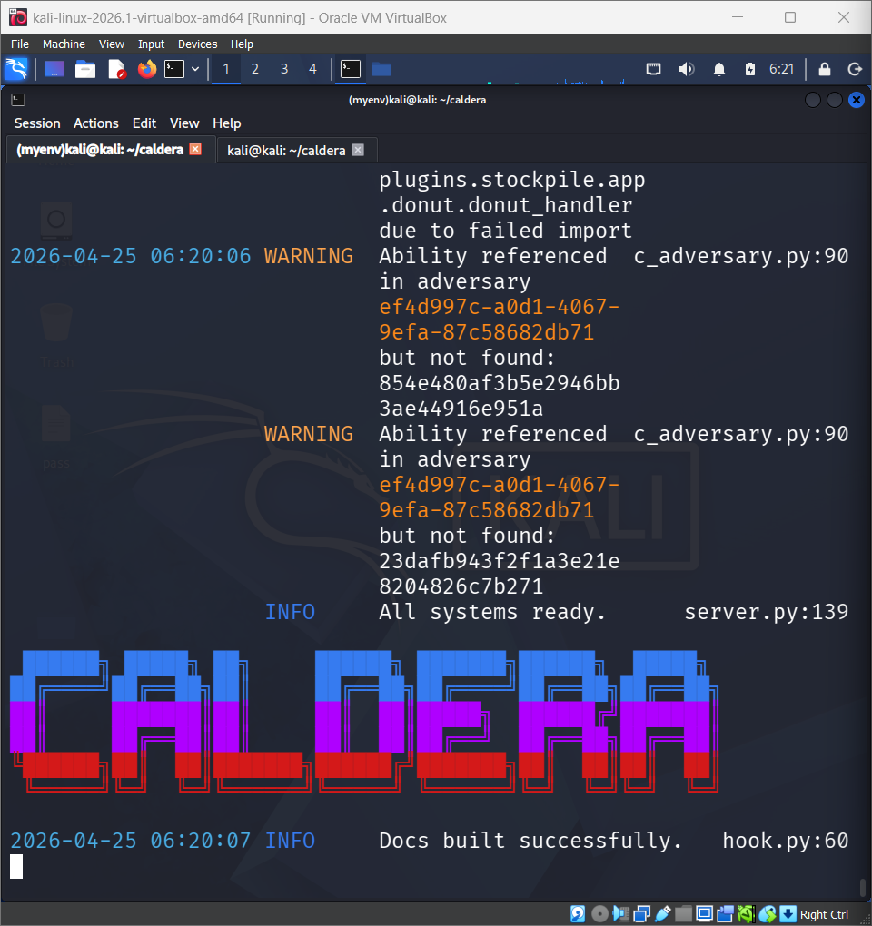

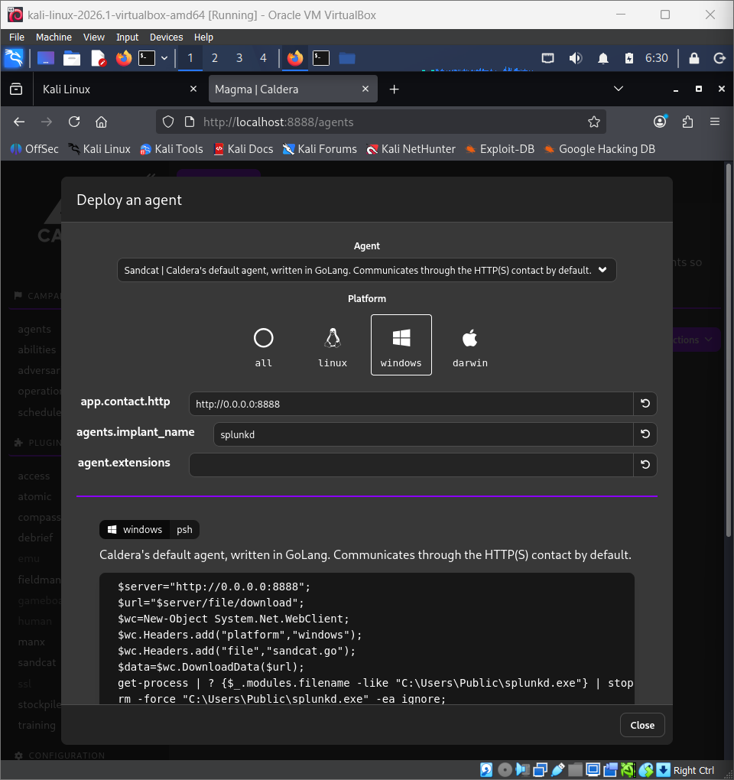

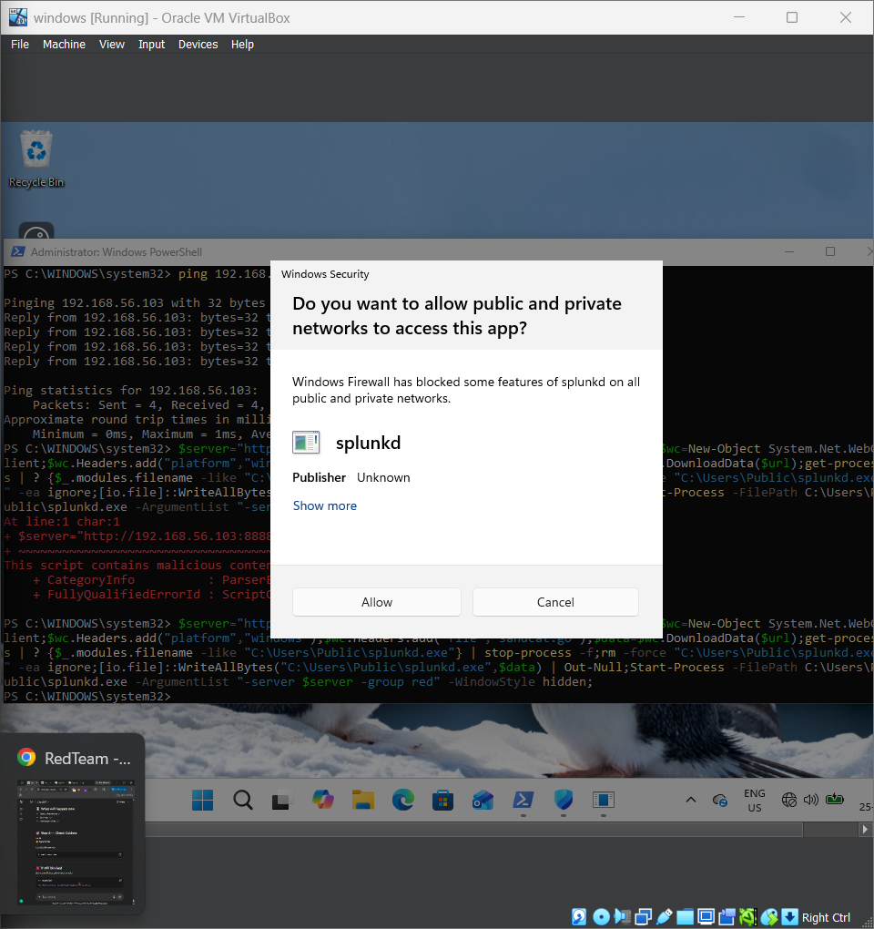

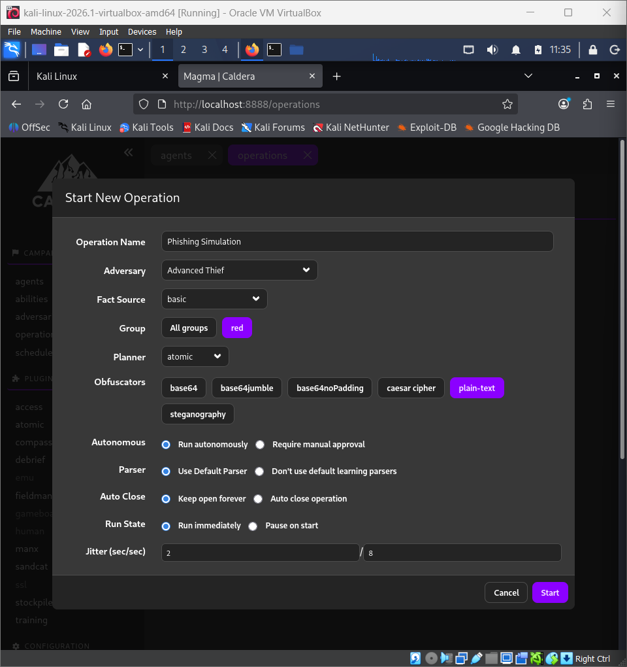

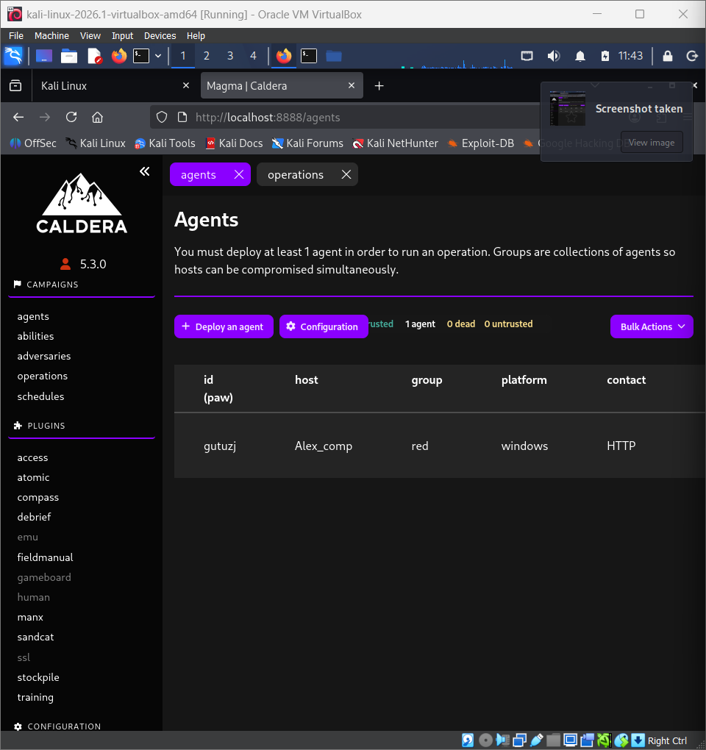

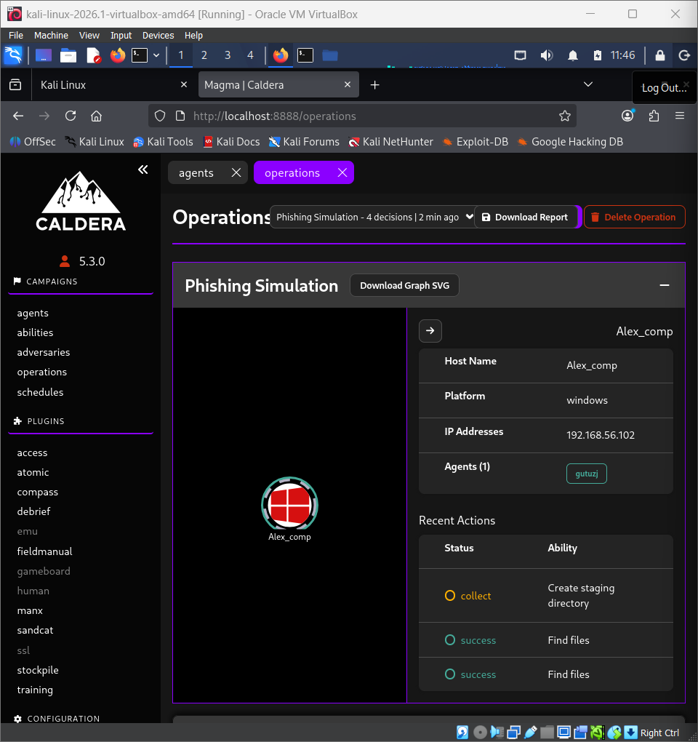

8. Conclusion

The analysis confirms that the system is operating under normal conditions with no evidence of compromise. All observed processes and network activities were legitimate and aligned with expected Windows behavior.

